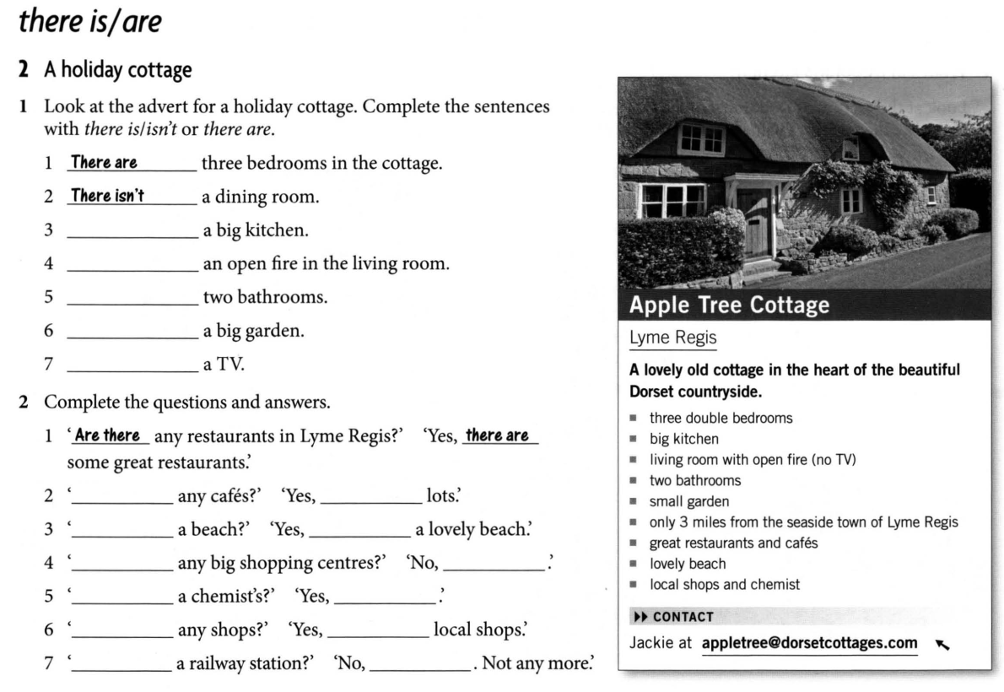
H/T
You are a real estate agent.
Find a picture of a house, an apartment or a cottage and sell it to me.
Be ready to speak.

